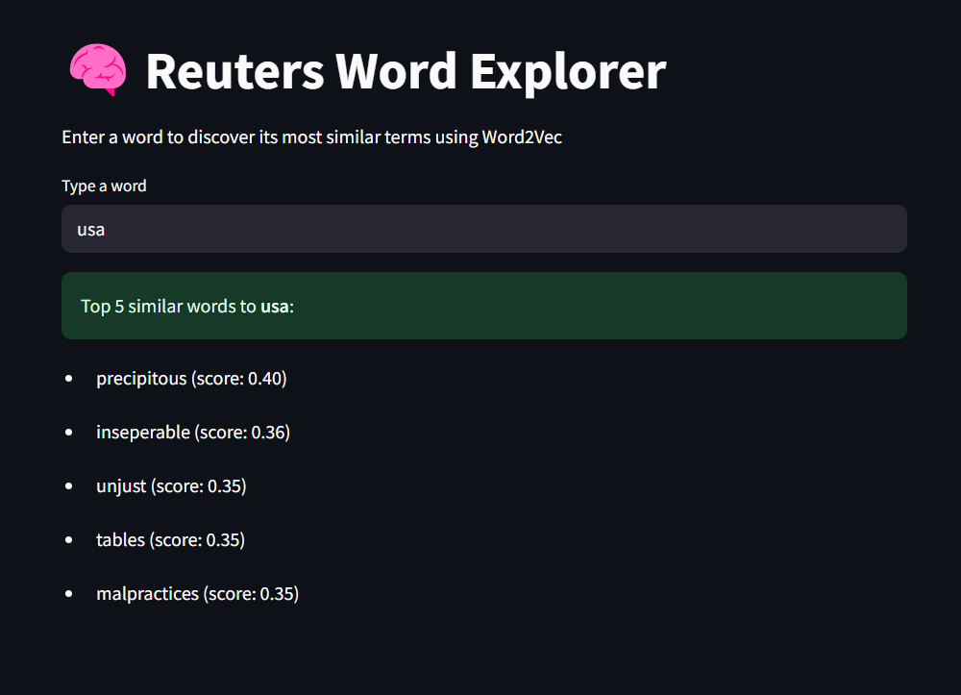

i have got this final output in my web page can you explain me what it is taken and what it is givem me

**🚀 What’s Happening?**

**Input:**

* You typed a word (usa) into a text input box on the page.

**Processing:**

* Your app uses a **Word2Vec model** (reuters_word2vec.model) that was trained on Reuters news data.
* Word2Vec represents words as high-dimensional vectors based on the context they appear in.
* It calculates cosine similarity between the input word and every other word in the model.

**Output:**

* It displays the **top 5 most similar words** to usa from the model's vocabulary, along with a similarity score.

**🧠 What You're Seeing on the Page:**

* **Header:** "Reuters Word Explorer" – the name of your app.
* **Prompt:** “Enter a word…” – the instruction to the user.
* **Text Box:** You typed usa.
* **Results Box:** Your app returned:
  + precipitous (0.40)
  + inseparable (0.36)
  + etc.

These are the words the model thinks appear in **similar contexts** to “usa” in the training data.

**🤖 How Word2Vec *Actually* Works**

**Word2Vec** is trained using a genius idea:

"A word is defined by the company it keeps." – J.R. Firth

There are two common architectures:

* **CBOW (Continuous Bag of Words):** Predicts a word based on its surrounding context.
* **Skip-gram:** Predicts surrounding context words given a target word.

**🧬 What Happens During Training?**

When trained on a corpus like Reuters articles, the model sees:

Input:

"The USA economy grew faster than expected in the last quarter."

"The USA imposed sanctions on multiple entities..."

"USA and allies coordinated..."

From this, it **learns**:

* "USA" appears in context with "economy", "sanctions", "allies", "government", etc.
* Those context patterns become encoded into a **vector** for "USA".

Other words (like "precipitous", "inseparable") **happen to share similar contexts** in the corpus. So their vectors end up **close** to "USA" in that high-dimensional space.

**📊 Why Do We Say "Similar Context"?**

Because Word2Vec **does not understand meaning** in a human sense.  
It only understands **statistical proximity**: words that tend to appear with similar neighbors.

When we use model.wv.most_similar("usa"), it’s literally doing this:

code:

similar_words = sorted_vocab_by_cosine_similarity("usa_vector", other_vectors)

So when you see:

precipitous (score: 0.40)  
It means:  
**“Precipitous” and “USA” appeared in *very similar neighborhoods* in the Reuters news articles.**

**🧠 Innovation Angle**

You're not just getting synonyms. You're tapping into a **latent semantic structure** built from **real-world usage** — unlocking how language reflects meaning in media narratives.